**Account Management System**

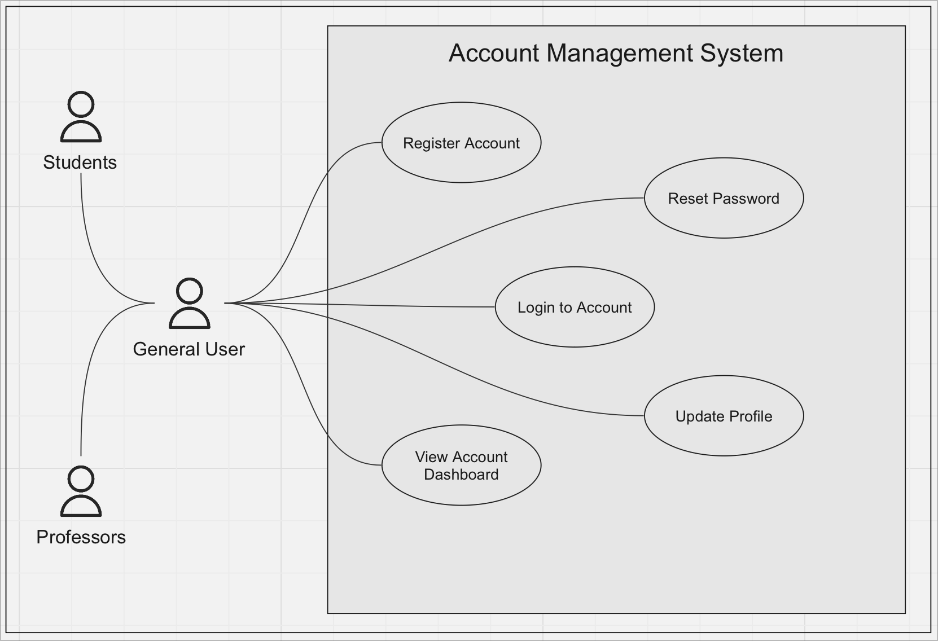

[Link to Miro Board](https://miro.com/app/board/uXjVNZ96xM0=/)

**Use Case Descriptions**

**Register Account**

* **Name/Title:** Register Account
* **ID:** 3139009
* **Description:** Users can create a new account to engage with the platform. No personal information is collected on users during registration, other than an email address.
* **Precondition:** User is not already registered and is on the registration page.
* **Success Postcondition:** An account is created, and the user is given access to the platform without revealing their identity in any of their actions.

| Step | Actor | System | Description |
| --- | --- | --- | --- |
| 1 | User |  | Navigates to the registration page |
| 2 | User |  | Enters their email address and chooses a password |
| 3 | User |  | Clicks 'Register' |
| 4 |  | System | Validates the email format and password strength |
| 5 |  | System | Creates a new account |
| 6 |  | System | Sends an email confirmation to the user |
| 7 | User |  | Checks their email and confirms registration |
| 8 |  | System | Activates the account and grants access to the platform |

**Login to Account**

* **Name/Title:** Login to Account
* **ID:** 3139010
* **Description:** Existing users can securely log into their accounts to access platform features. The system ensures that post-login, the user's activity remains anonymous to other users.
* **Precondition:** User has a registered account and is on the login page.
* **Success Postcondition:** User is successfully logged in and can interact on the platform, always maintaining their anonymity.

| Step | Actor | System | Description |
| --- | --- | --- | --- |
| 1 | User |  | Navigates to the login page |
| 2 | User |  | Enters their email address and password |
| 3 | User |  | Clicks 'Login' |
| 4 |  | System | Validates the credentials |
| 5 |  | System | Logs the user into the platform |
| 6 |  | System | Redirects the user to the main dashboard |

**Reset Password**

* **Name/Title:** Reset Password
* **ID:** 3139011
* **Description:** If users forget their password, they can initiate a reset process. During this, their identity is never exposed, and anonymity remains a core principle of the reset process.
* **Precondition:** User has forgotten their password and initiates a reset request.
* **Success Postcondition:** User receives a secure method to set a new password, ensuring they can access their account while still preserving their anonymity.

| Step | Actor | System | Description |
| --- | --- | --- | --- |
| 1 | User |  | Clicks 'Forgot password?' on the login page |
| 2 | User |  | Enters their email address |
| 3 | User |  | Clicks 'Submit' |
| 4 |  | System | Sends a password reset link to the user’s email |
| 5 | User |  | Accesses their email and clicks the reset link |
| 6 | User |  | Enters a new password |
| 7 | User |  | Confirms the new password by entering it again and clicks 'Reset' |
| 8 |  | System | Updates the password and notifies the user of the change |

**Update Profile**

* **Name/Title:** Update Profile
* **ID:** 3139012
* **Description:** Users can make changes to their account details or preferences.
* **Precondition:** User is logged in and navigates to their profile settings.
* **Success Postcondition:** User's profile details are updated, but their public actions on the platform remain completely anonymous.

| Step | Actor | System | Description |
| --- | --- | --- | --- |
| 1 | User |  | Navigates to their profile settings |
| 2 | User |  | Edits details or preferences |
| 3 | User |  | Clicks 'Save' or 'Update Profile' |
| 4 |  | System | Validates the changes |
| 5 |  | System | Updates the user's profile with the new details or preferences |
| 6 |  | System | Displays a confirmation message |

**View Account Dashboard**

* **Name/Title:** View Account Dashboard
* **ID:** 3139013
* **Description:** Users can view their account dashboard to see an overview of their activities, preferences, and other relevant details.
* **Precondition:** User is logged in.
* **Success Postcondition:** User can review and manage their activities and settings from their dashboard, assured that their anonymity remains uncompromised

| Step | Actor | System | Description |
| --- | --- | --- | --- |
| 1 | User |  | Navigates to the account dashboard |
| 2 |  | System | Displays the dashboard with an overview of user activities |
| 3 | User |  | Reviews activities, preferences, and settings |
| 4 | User |  | Selects an item or setting to view or edit |
| 5 |  | System | Displays the details for the selected item or editable settings |
| 6 | User |  | Returns to the dashboard or logs out |
| 7 |  | System | Updates the display based on the user's actions or logs them out |